**Please find below screenshots to see flow of an application:**

1. Below web page open when user visit application to login(use “Ravina123” id to login as an admin)

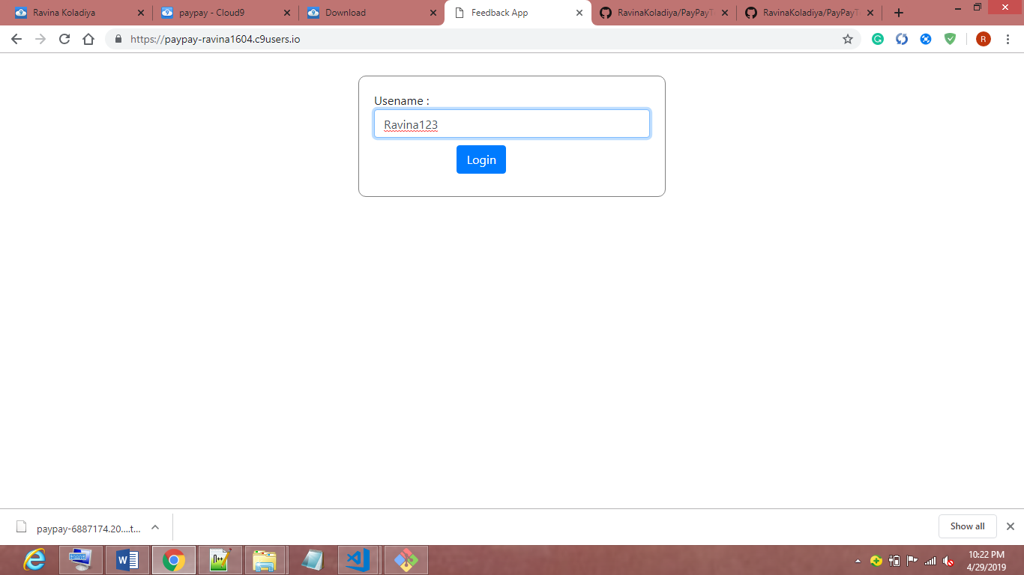

1. Once user login as an admin into the system it will show employees present in database.

And show “Add employee”(to add new employee) and “Show All Employes” button

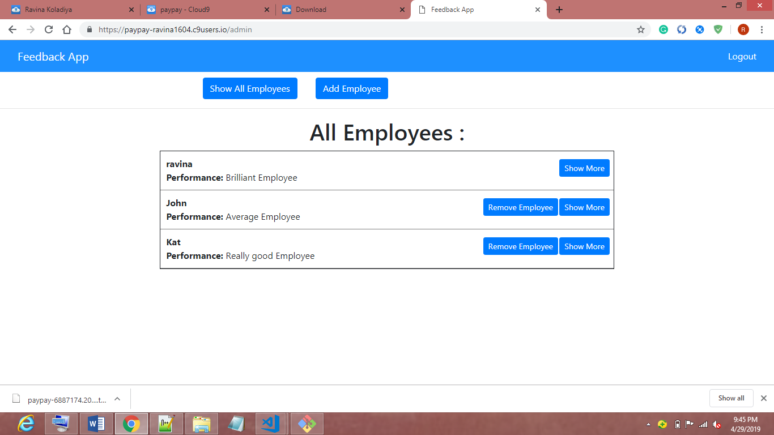

1. Once user clicks on “Add Employee button” it will open form with fields to add new employee into system.

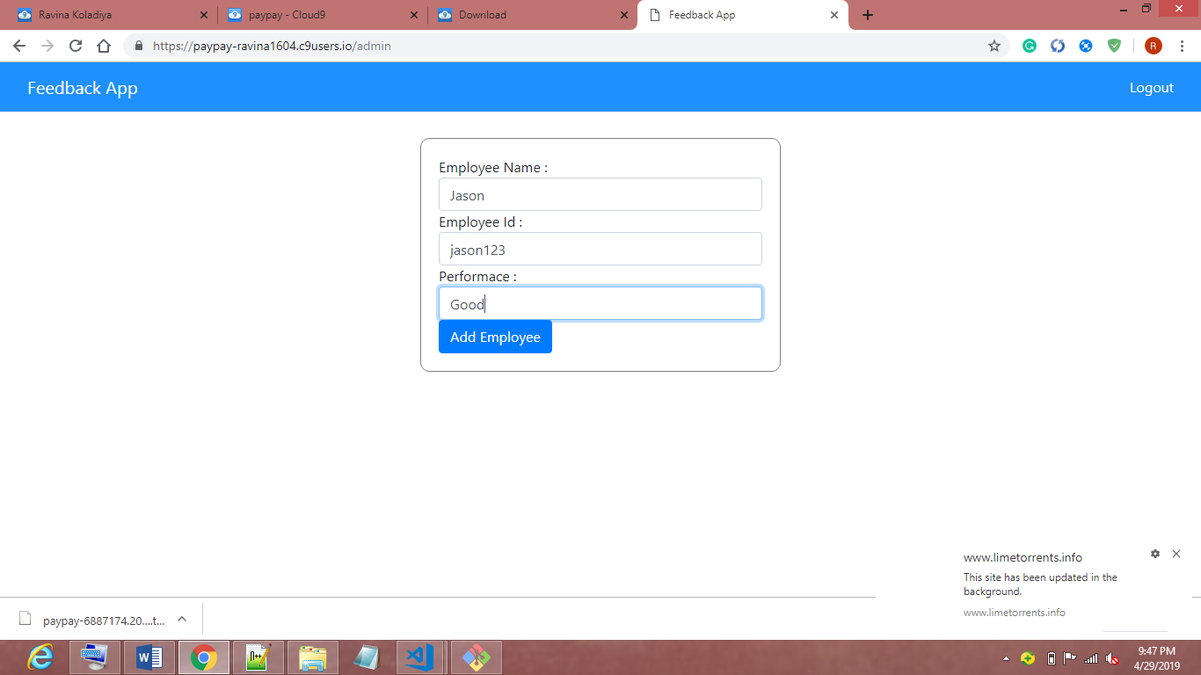

1. When user clicks on “Add Employee button” after filling all details in form , employee will get added into system and we can show it in all employees section”.

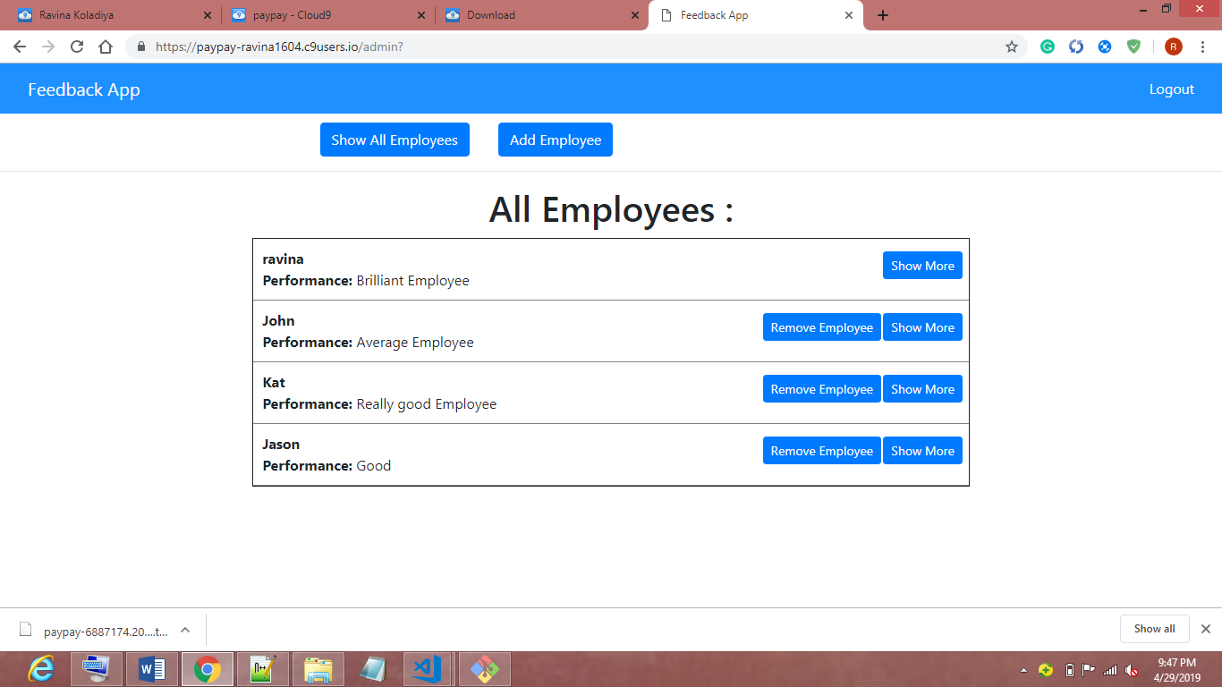

1. When user clicks on any one of “Remove Employee” button it will remove particular employee from system and will get reflected in “all Employees” section.

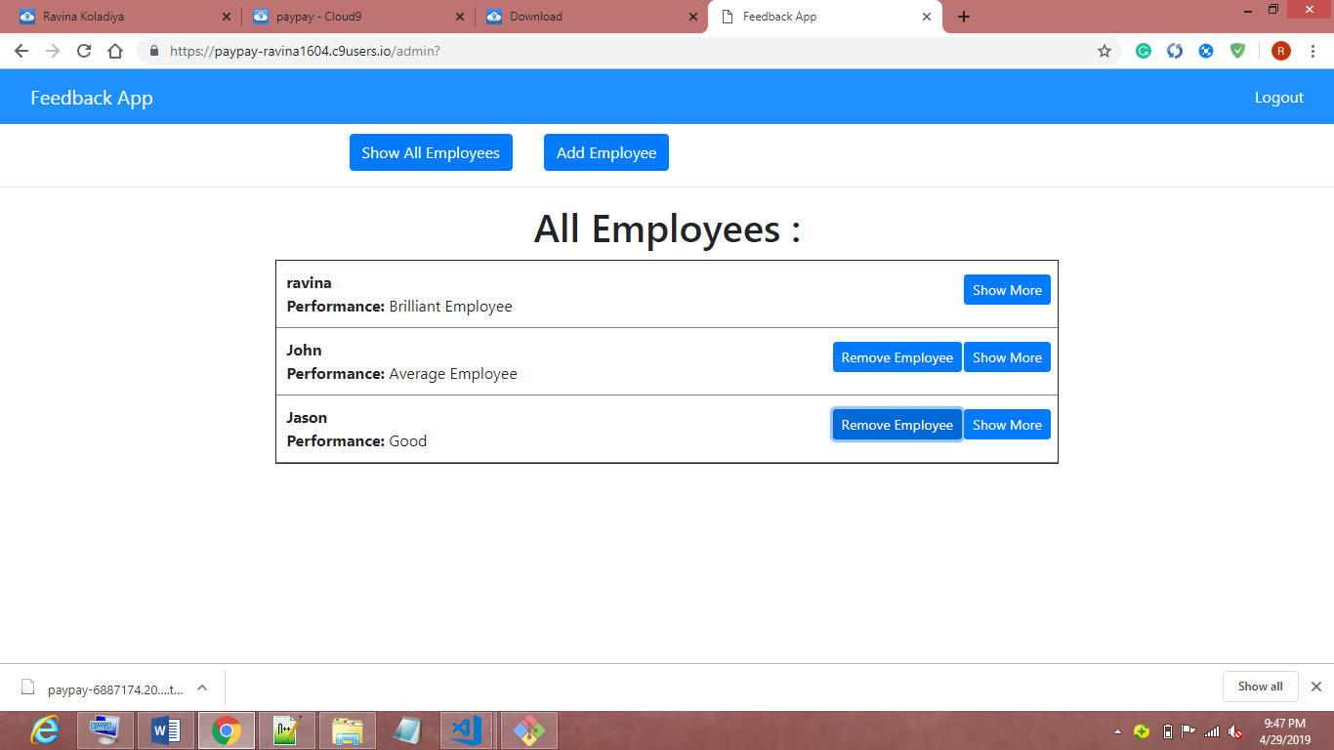

1. If user clicks on “Show more” button for particular employee it will open below web page to show extra detail(e.g. performance, all feedbacks given by employee) of particular employee.

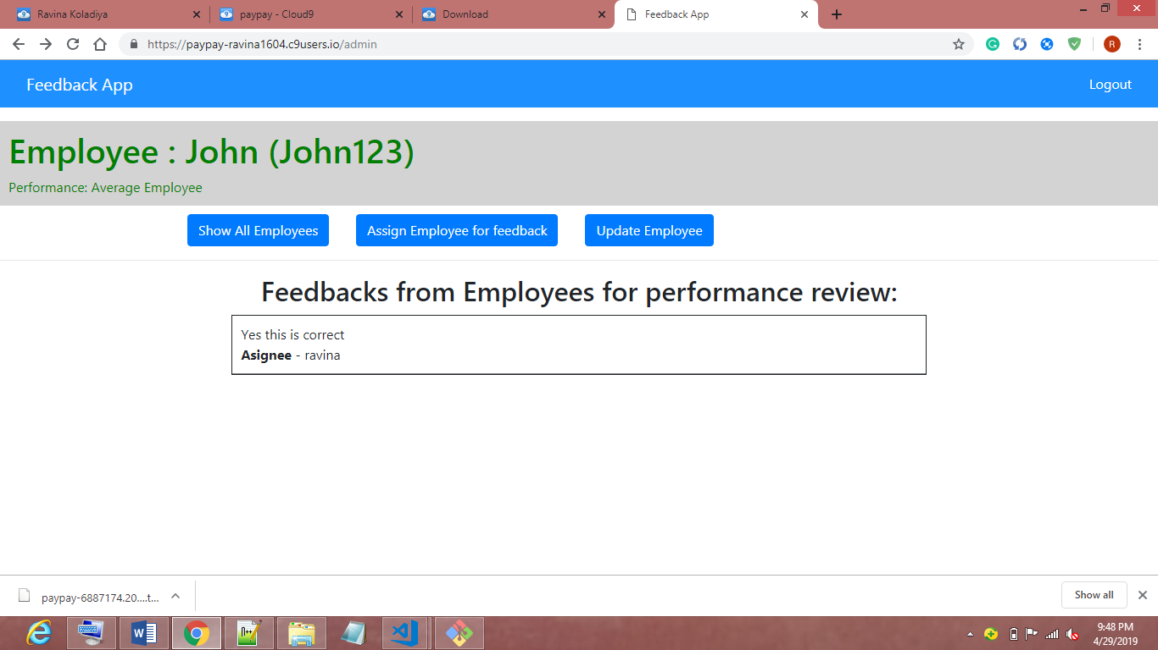

1. If user clicks on “Assign Employee for feedback” button to assign employee to give feedback for particular employee’s performance, it will open below page to select employee.

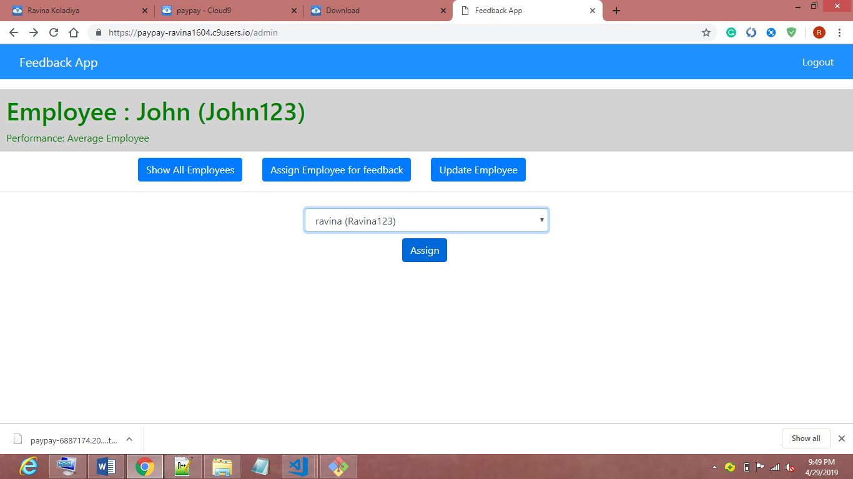

1. When admin clicks on “Update Employee” button it will open below form with existing details to update particular employee.

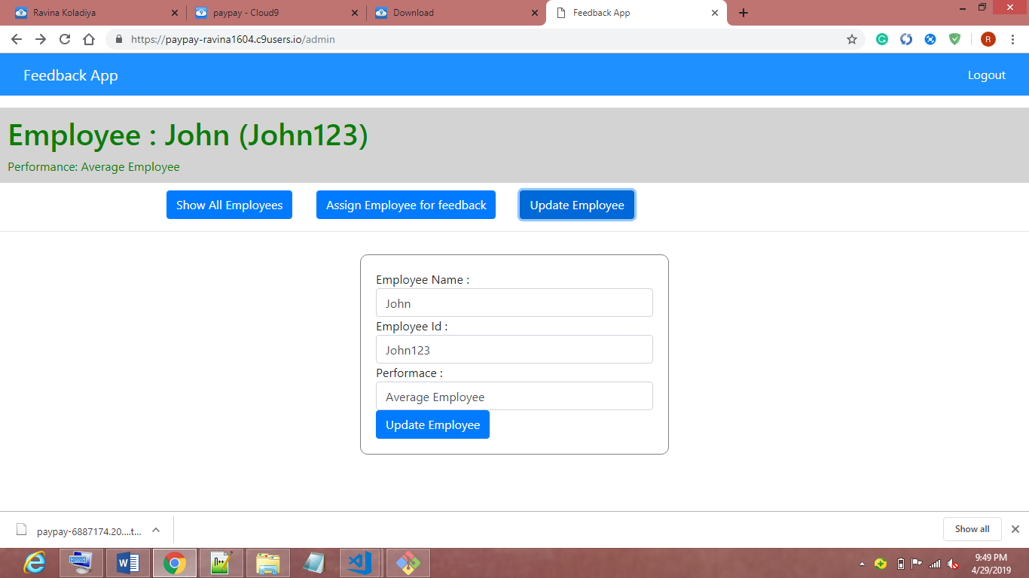

1. To login as a user enter valid userName (e.g. “John123” or “Kat123” if not deleted).

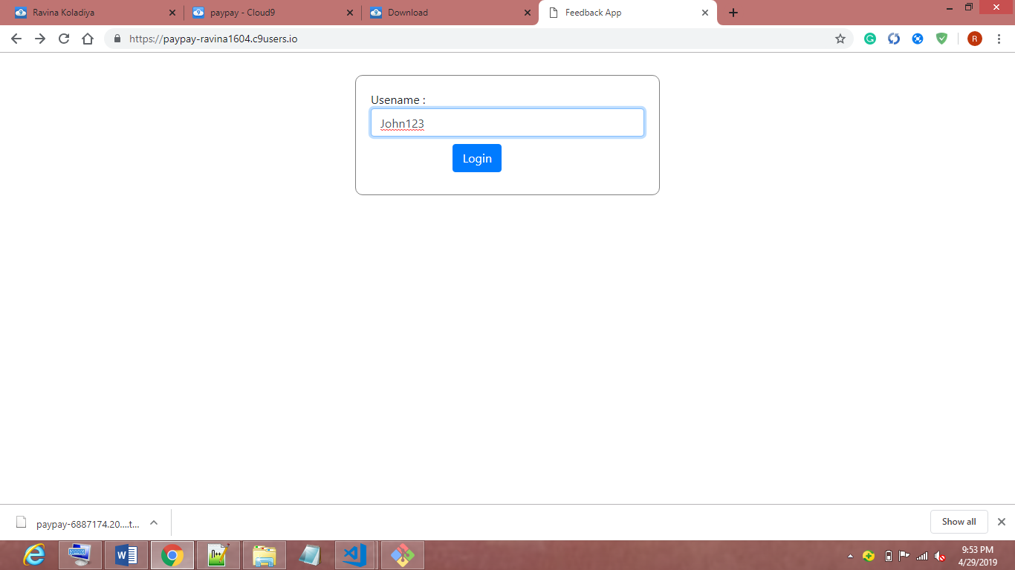

1. Once user logged in into the system it will show performance and all feedbacks given for his/her performance.

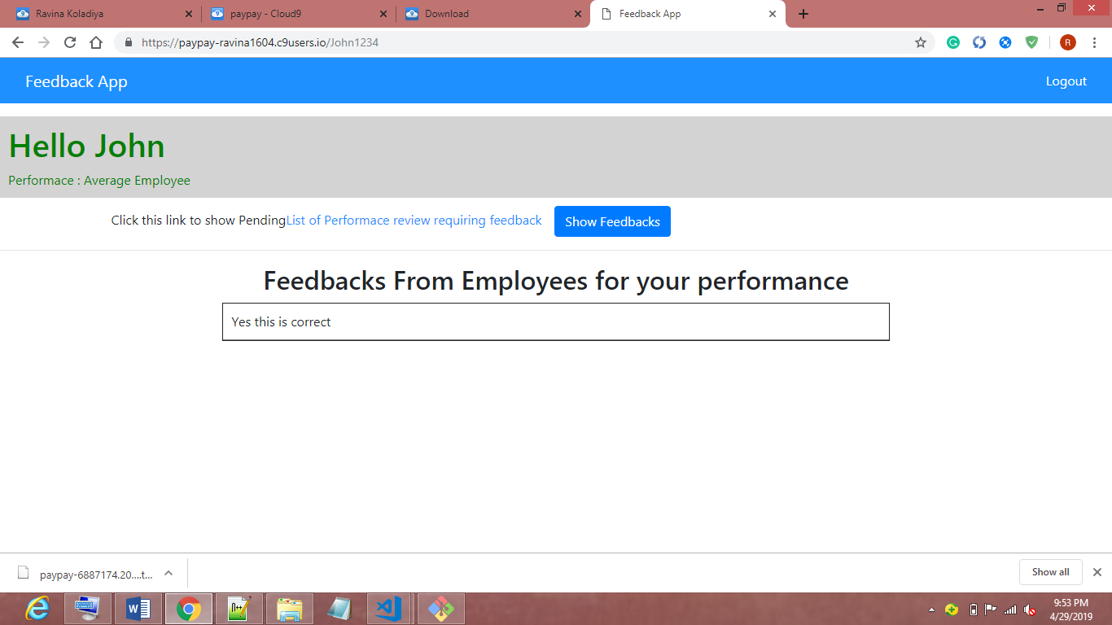

1. Once user clicks on “List of performance review requiring feedback ” link it will open below webpage with all employee for which you(logged in user) need to provide feedback.

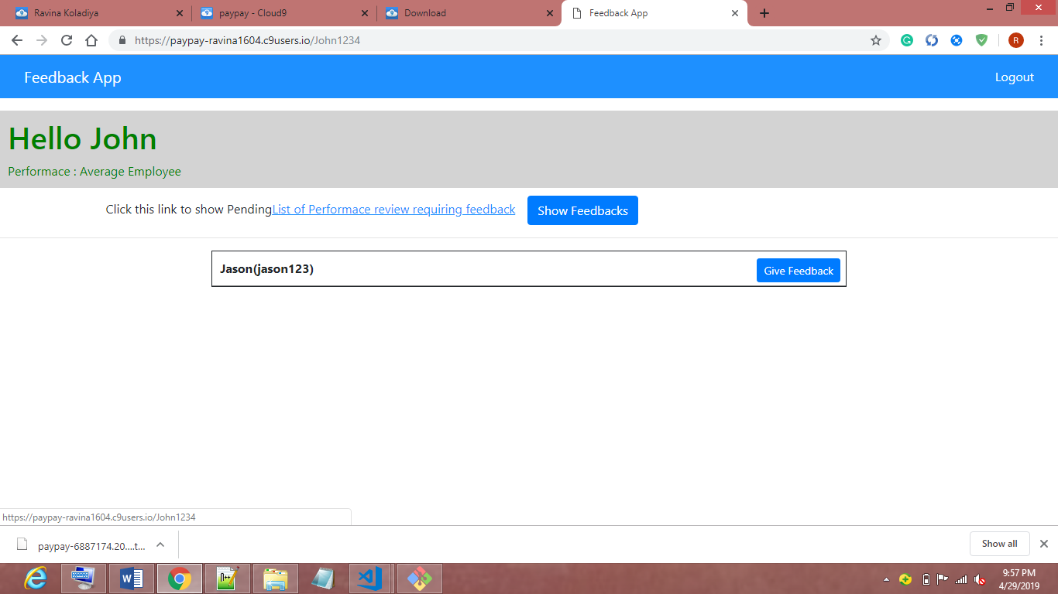

1. When user clicks on “Guve feedback” button it will open below form to add feedback for employee’s performace review.

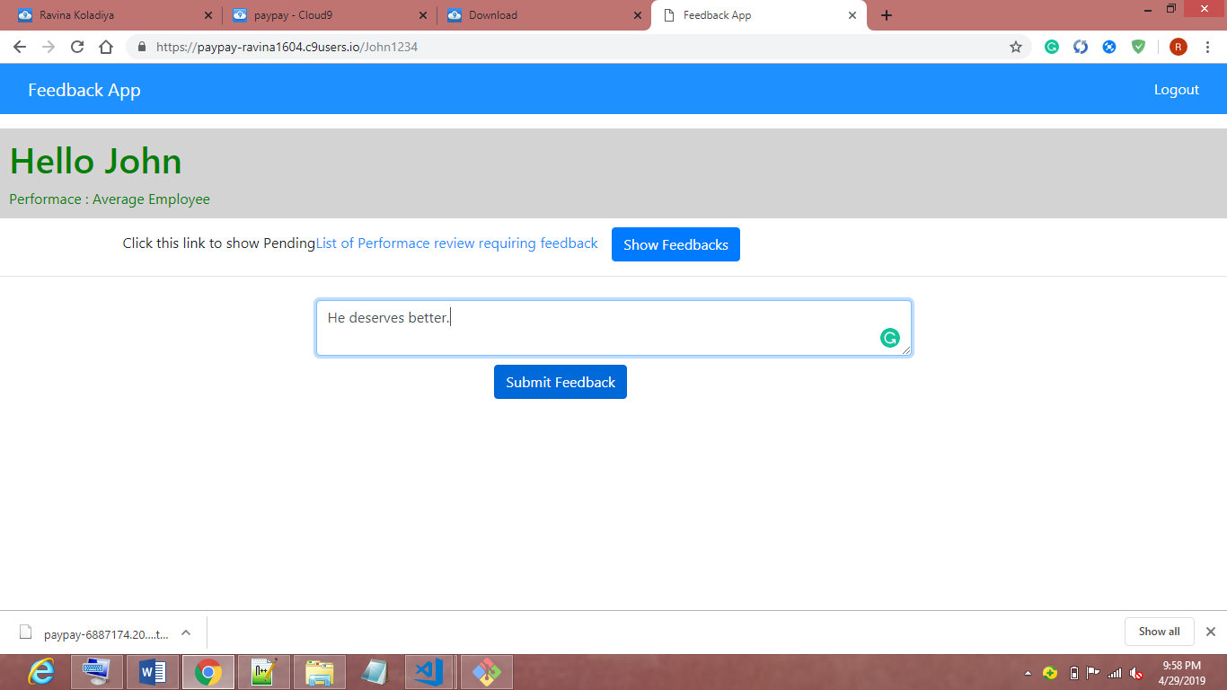

1. Once user give feedback for particular employee it will remove from list one by one.

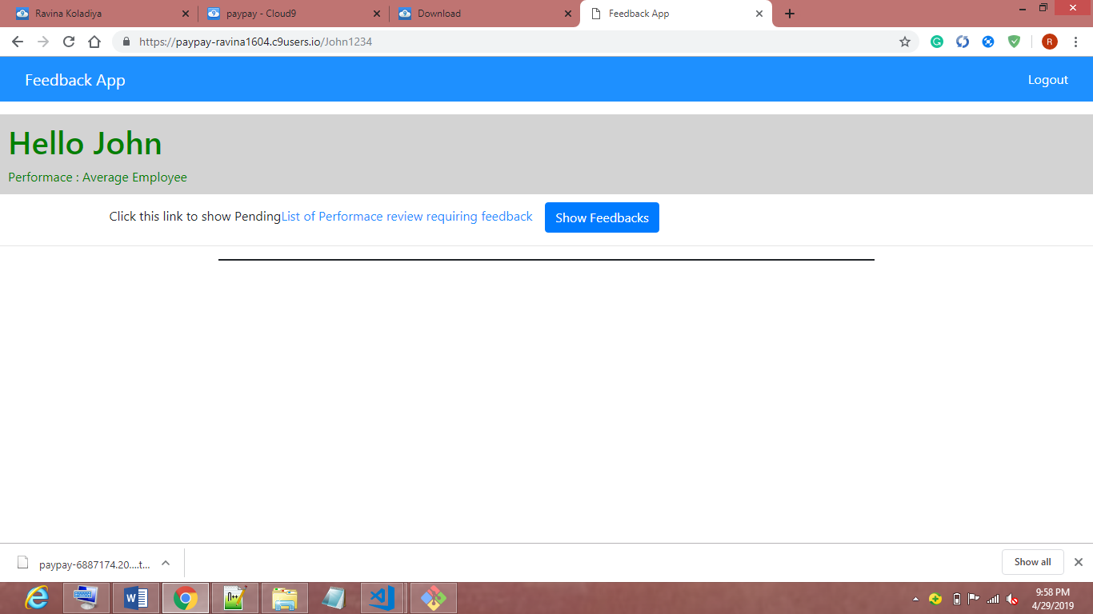

1. And you can see changes. Feedback will get reflected in that employee’s feedback list if we login into the system as that employee.

